Lora NS Docking Instructions - The Things Stack
Directory
1. Overview 2
2. Lora Device Description 2
3. Gateway configuration 4
4.The Things Stack-SANDBOX Docking 5
4.1 Registration and Login 5
4.2 Add Gateway 6
4.3 Add Device 7
5. LoRa Application Server Docking 10

1. Overview
LoRaWAN is a low-power local area network wireless standard developed by Semtech, which aims to solve the contradiction between power consumption and transmission coverage distance. Generally, low power consumption means short transmission distance, and high power consumption means long transmission distance. By developing LoRaWAN technology, it solves the technical problem that the transmission distance is longer than other wireless methods under the same power consumption conditions, and realizes the unity of low power consumption and long distance. This document is still being updated and maintained. If there are any errors or omissions, please contact the relevant personnel for correction. Thank you.
Therefore, LoRaWAN is widely used in low-power consumption and private network deployment. A complete LoRaWAN system includes the following parts:
1: Terminal equipment with LoRaWAN module
2: LoRaWAN gateway
3: LoRa Network Server (lora ns)
4: LoRa Application Server (lora as)
At least the first three parts are required to form an independent LoRaWAN system. Because countries around the world are optimistic about the prospects of LoRaWAN, more and more companies have joined the development of LoRaWAN devices, and more open source architectures about LoRaWAN have been developed. This greatly reduces the threshold and cost for people to use LoRaWAN.
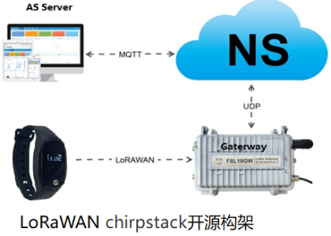
This document will provide a brief description of the deployment, implementation, and troubleshooting of the entire system.
The purpose is to avoid detours and deploy the LoRaWAN system faster and more conveniently.
The document will provide a brief description of lora device instructions, gateway configuration, The Things Stack docking, and LoRa application server docking.

2. Lora Device Description
Currently supported Lorawan protocol device models are:
Watch models: W200PL; W200PLU; W300L
Bracelet model: B2315L
Work card and locator models: G805L, G808L, G818L, G618L
Watch model description:
General version: The default high-frequency general purpose is AS923 (923.2-924.6) | The low-frequency general purpose is CN470 (470.3-471.7), ABP-CLASSA. If other frequency bands are required, please submit your request.
Device EUI (DevEUI): Click the down button on the watch to switch the display interface, click to switch to Settings - About interface to view, and you can also view it on the outer packaging box.
Join EUI (APPEUI): Click the down button on the watch to switch the display interface, click to switch to Settings, click to select the About interface, and you can view this parameter on the About interface.
Related communicationkey:--You can view the specific model communication protocol, or refer to the following
OTAA:
Application key: 2B7E151628AED2A6ABF7158809CF4F3C
ABP:
Device address: Last eight digits of watch DEVEUI
Application session key: EF6D6E2503F57AE2FA151CDA87455F18
Network session key: 2E8C8650B4041672BBB9A399F2DEB427
Bracelet model description:
General version: The default high-frequency general purpose is AS923 (923.2 - 924.6), the low-frequency general purpose is CN470 (470.3 - 471.7), ABP-CLASSA. If other frequency bands are required, please submit your request.
Device EUI (DevEUI): Click the button on the watch to switch the display interface. Click to switch to the About interface. Wait on the About interface, and the interface will automatically switch to display. You can view the corresponding parameters. You can also view it on the outer packaging box.
Join EUI (APPEUI): Click the down button on the watch to switch the display interface. Click to switch to the About interface. Wait on the About interface, and the interface will automatically switch to display. You can view the corresponding parameters.
Related communicationkey:--You can view the specific model communication protocol, or refer to the following
OTAA:
Application key: 2B7E151628AED2A6ABF7158809CF4F3C
ABP:
Device address: Last eight digits of bracelet DEVEUI
Application session key: 2B7E151628AED2A6ABF7158809CF4F3C
Network session key: 735F2F22103042BE724197AC1727EA94
Explanation of model of work card and locator:
General version: The default high-frequency general purpose is AS923 (923.2-924.6) | The low-frequency general purpose is CN470 (470.3-471.7), ABP-CLASSA. If other frequency bands are required, please submit your request.
Device EUI (DevEUI): There are relevant stickers on the work card for viewing, and it can also be viewed on the outer packaging box.
Join EUI (APPEUI): The default work card is consistent with the watch APPEUI, generally: d896e0e000005203
Related communicationkey:--You can view the specific model communication protocol, or refer to the following
OTAA:
Application key: 2B7E151628AED2A6ABF7158809CF4F3C
ABP:
Device address: Last eight digits of watch DEVEUI
Application session key: EF6D6E2503F57AE2FA151CDA87455F18
Network session key: 2E8C8650B4041672BBB9A399F2DEB427

3. Gateway configuration
Gateways that support the lorawan protocol can be connected.
For different gateways, the login interface and pages are different. If it is a gateway shipped by our company, please refer to the operation manual.
There are also related configuration videos in the following chapters.
The main points to note are as follows:
1.loraGatewayloraCommunication frequency band: It needs to be matched with theloradevice terminal
2.loraGateway pointing, needs to point tolora ns,Lora nscan establish contact with the gateway,
Taking chirpstack as an example, the Lora gateway needs to point to the IP address (internal or public network) of the computer where chirpstack is installed, with the UDP port 1700.
3.loraThe gateway needs to be in the same network aslora ns. If there is only an internal network, the gatewayipandlora nsneed to be under the same gateway.
For example:loraGatewayIPis192.168.1.11, the subnet mask is255.255.255.0, and the default gateway is192.168.1.1
lora ns IPIPis192.168.1.33, the subnet mask is255.255.255.0, and the default gateway is192.168.1.1
If it is a public network, both need to access the public network

Note: Connecting toThe Things Stackcloud network service requires the gateway to connect to the public network

4.The Things Stack-SANDBOX Docking
The Things Stack is an open-source LoRaWAN network server developed by The Things Industries and is widely used in the field of Internet of Things.
The Things Stack supports the use of The Things Stack's corresponding cloud network services, and also supports the local private deployment of NS.
This document is mainly used to describe the docking of The Things Stack's corresponding cloud network service The Things Stack-SANDBOX. For the local private deployment method, see the official document
Official website:https://www.thethingsindustries.com/docs/

4.1 Registration and Login
(1) The Things Stack-SANDBOX supports free registration and access, website:https://id.thethingsnetwork.org/
Note: The website is a foreign website in China, and access will be slow, which is normal.
(2) Click Register, enter your email address and related items to register.
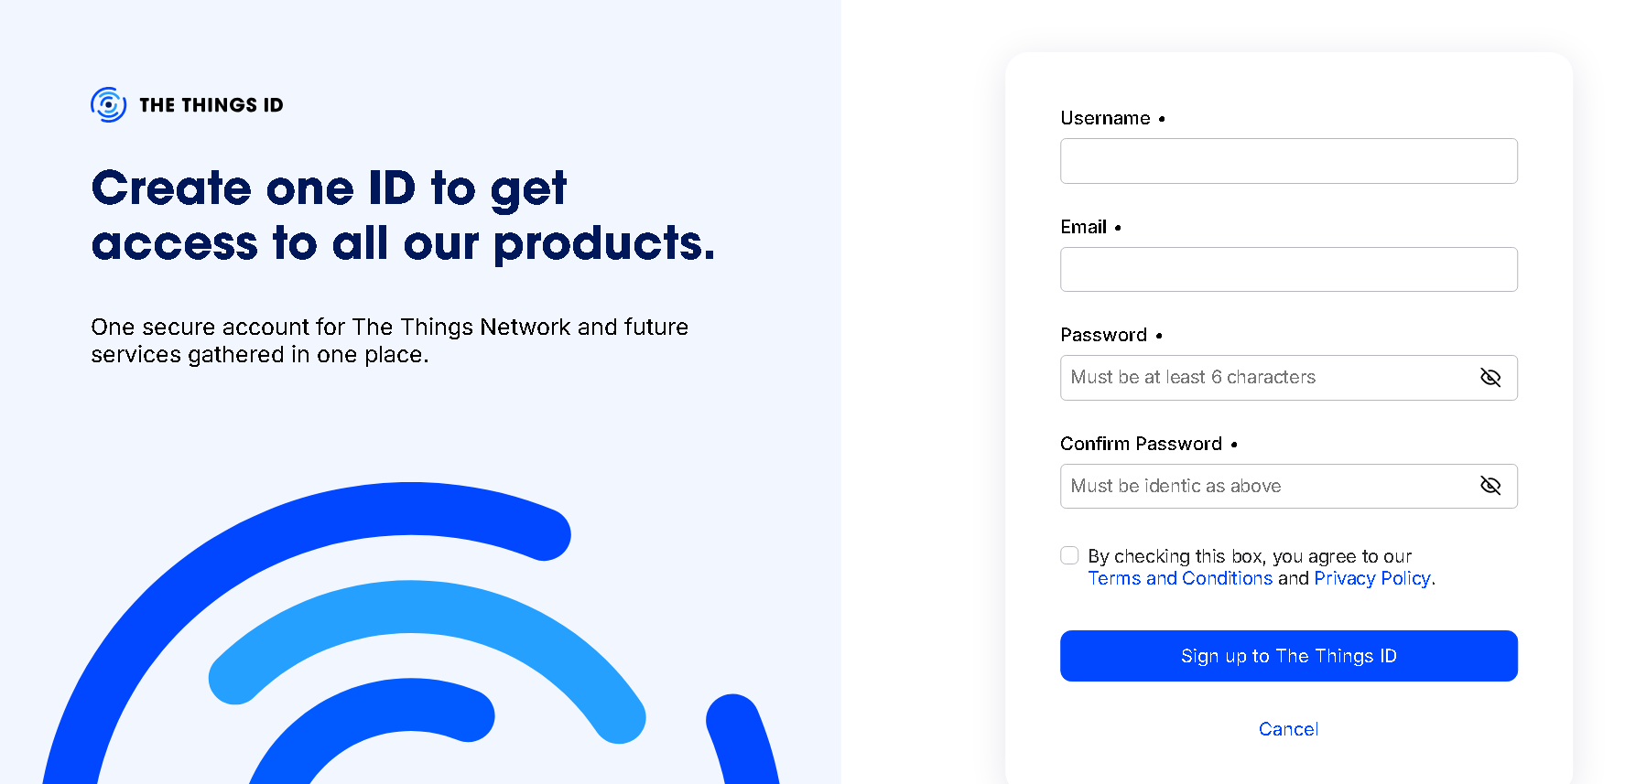
(3) After registration, select the appropriate region according to your actual environment and log in.

4.2 Add Gateway
(1) After logging in, the default interface is the Application page. Switch to the Gateway interface and click
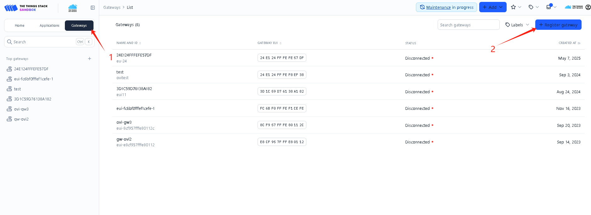
(2) Enter the corresponding gateway EUI, click confirm, enter the corresponding gatewayid and select the corresponding lora frequency band
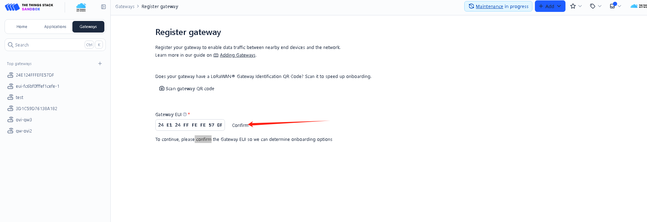
(3) After entering, click register gateway to complete the gateway registration
Complete operation video (taking LG620-CN470 gateway adding TTN as an example) is as follows:

4.3 Add Device
(1) Switch to the Application page, click add application, add an application, and customize the relevant content
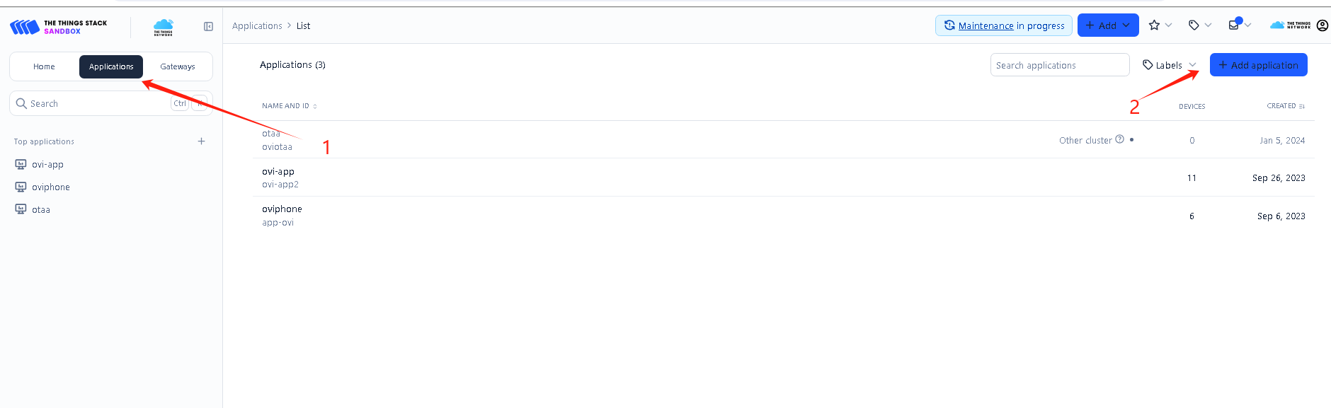
(2) After creating the Application, click the application name to enter the specific page, click +register end devices
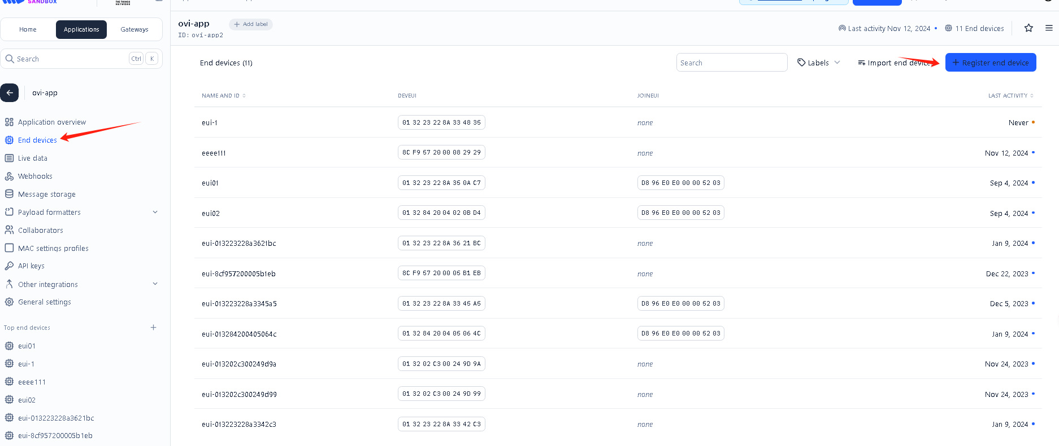
(3) Enter the information about the interface corresponding to the device on this interface. The frequency for China is CN470 and for Hong Kong Asia is 923-925. The following figure takes AS923 as an example and enters the relevant parameters
Field description:
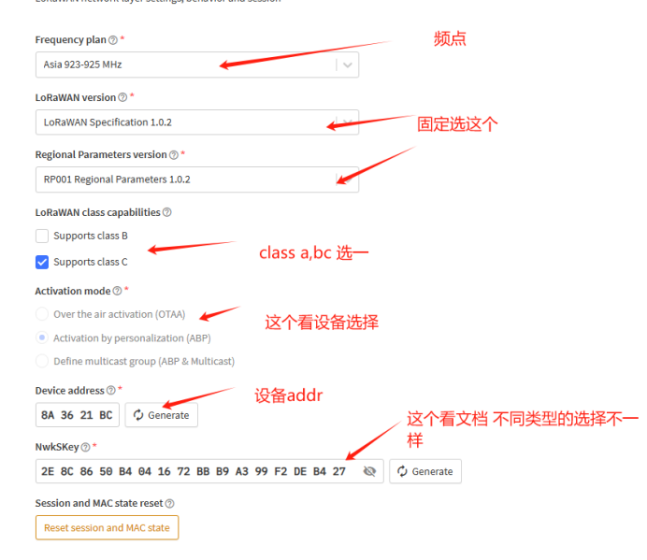
(4) Click register after entering
Complete operation video (taking B2315L-CN470-ABP-CLASSA adding as an example) is as follows:
Device related parameters see 2.lora device description
- After completing the above operations, you can view Live DATA and view data reporting
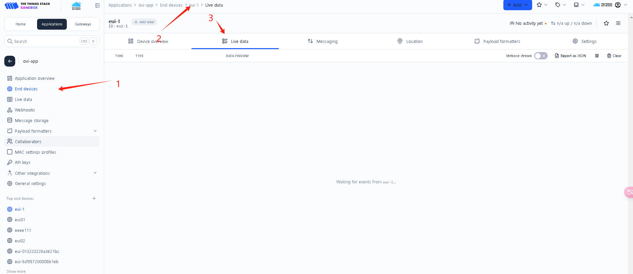
(6) If you do not see any reports, you can check the comparison in the interface below and confirm with the device whether you need to turn off ADR. Click Save after modification
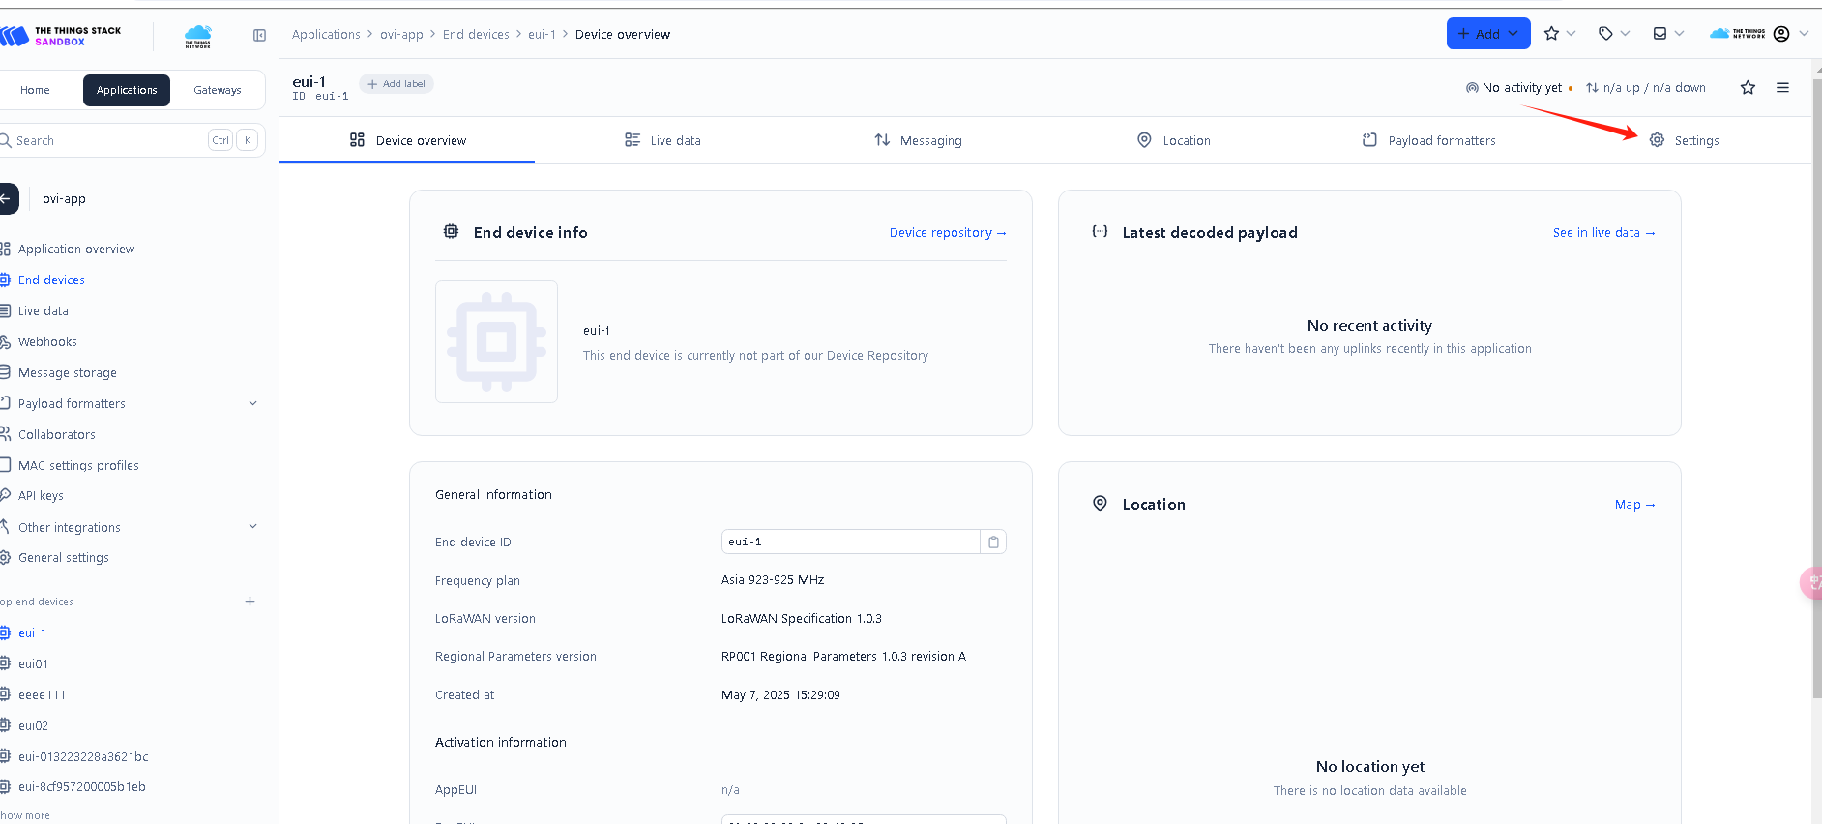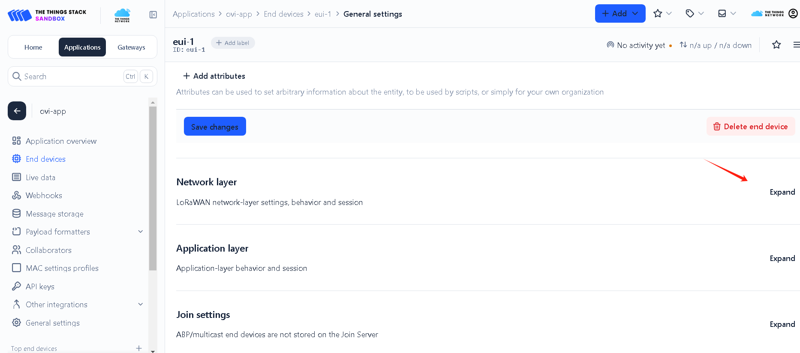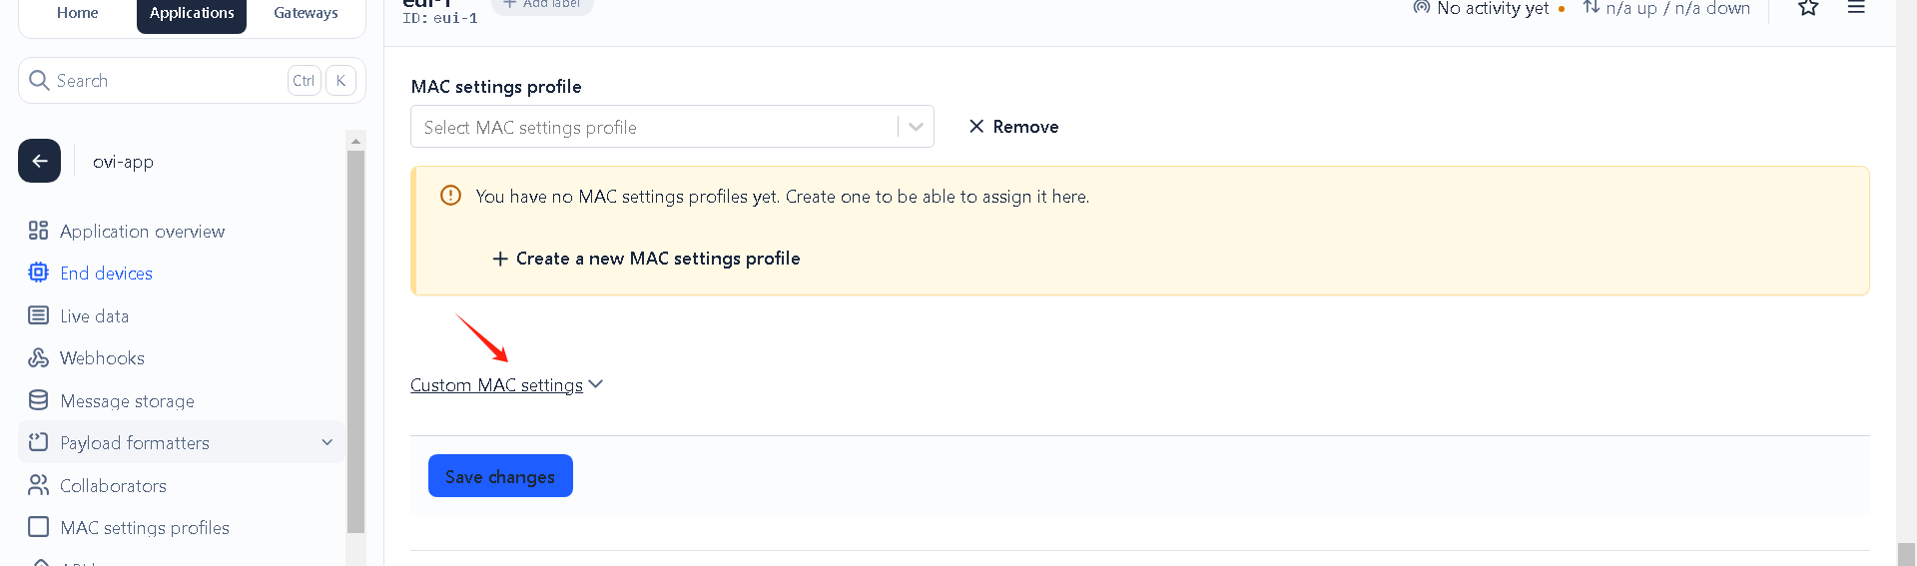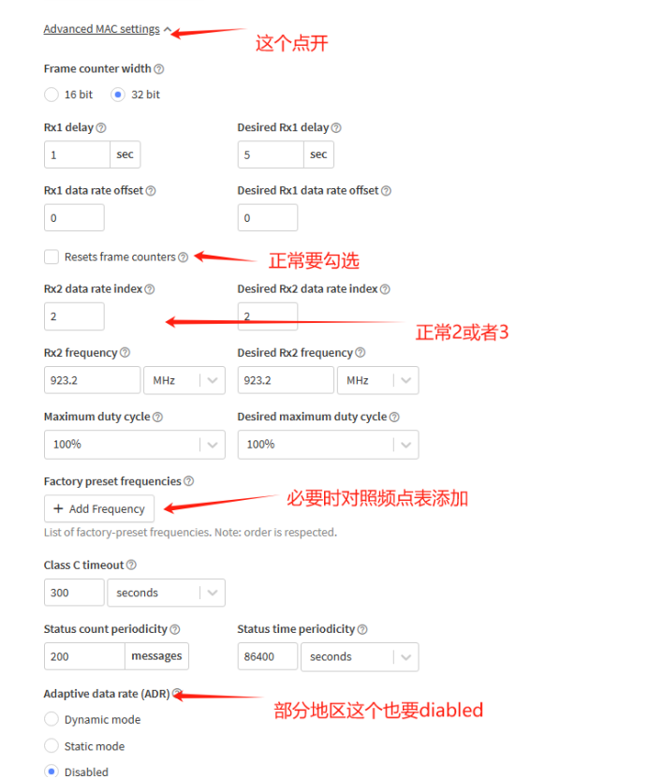

5. LoRa Application Server Docking
How do LoRa Network Servers and LoRa Application Servers interface with data? The Things Stack integrates many processing methods.
The following mainly introduces the MQTT method to interface with LoRa Application Servers, which is also a widely used method currently.
Official documentation:https://www.thethingsindustries.com/docs/integrations/other-integrations/mqtt/
(1) MQTT method to connect to LoRa application server
Uplink subscription topic:
v3/{Application ID}@ttn/devices/{device id}/up or v3/{Application ID}/devices/{device id}/up
Subscribe to all devices as: v3/{Application ID}@ttn/devices/#
Note: {application id} is a string of32-bit mixed characters and numbers ID. The above content has the content of creating an application, which can be viewed after creationid
{device id} is the device EUI code of the device
Uplink data structure: See the official documentation for specific definitions:https://www.thethingsindustries.com/docs/integrations/other-integrations/mqtt/
Example:
Downlink subscription topic:
v3/{Application ID}/devices/{Device ID}/down/push or v3/{Application ID}@ttn/devices/{device id}/down/push
Note: {application id} A string of 32 mixed characters and numbers ID. The above content has the content of creating an application. You can view the ID after creating it.
{device id} is the device's device EUI code
Downlink data structure: See the official documentation for specific definitions:https://www.thethingsindustries.com/docs/integrations/other-integrations/mqtt/
You can use relevant MQTT testing tools for testing. The following are the configuration items that need attention when using the MQTTFX tool:
